***Project Phase III***

***On­­­***

**3-D Multiplayer Game(Tic-Tac-Toe)**

**Submitted for the requirement of**

**Project course**

BACHELOR OF ENGINEERING

**COMPUTER SCIENCE & ENGINEERING**



**Submitted to: Priyanka Sharma(E6197) Submitted By: Sahul Kr. Parida(20BCS4919)**

**(Project Supervisor) Saksham Thakur(20BCS4970)**

**Sudhanshu Kumar(20BCS4953)**

**Co-Supervisor Signature**

**Archana Kumari (E13569)**

**DEPARTMENT OF COMPUTER SCIENCE & ENGINEERING**

**CHANDIGARH UNIVERSITY, GHARUAN**

**November 2022**

# 

**Table of Contents**

Preliminary Design

1: INTRODUCTION 3 - 7

2: ALGORITHM USED 8

3: AGENT 9-10

REFERENCES 10

**PRELIMINARY DESIGN**

# **1.1 Project Background**

3D game is interactive computer entertainment that is graphically presented in the 3D of height, width and depth. The addition of depth to 2D gaming enabled the exploration of virtual worlds with more realistic representation. Player can experience themselves inside the game while playing the game with a few views such first person and third person.

A role-playing game (RPG) is a game in which each participant assumes the role of a character, generally in a fantasy or science fiction setting, that can interact within the game's imaginary world.

This 3d game project contain a storyline held in Virtual World. This game is allowing player to play their own story in the campus and explore the whole campus in 3d form. All mission or task have information about the campus in real life. Player need to find themselves to complete the mission with help of hint and a map. After completing the story mode, player is able to play on free mode where they can explore whole campus without obstacle to be completed.

For this 3d game, this game only focus on Virtual World. This may not fully follow the detail but the 3d layout.

# **1.2 Problem Statement**

There are many problems occur among the player which influent by video games:

* Too many games are for entertainment only.
* Lack of promotion platform.
* Violent inside video game are uncontrollable.

# **1.3 Objectives**

This game is developed to promote Virtual World. As we know, each university have their own website or portal where people can know about the campus but this time new platform is developed to promote my own campus and entertain player. Besides that, this game is more to simulation. By developing the game, the concept of simulation is implemented in the form of game.

* To develop the game that have zero violent.
* To design 3D games that can promote and tell information about Virtual World.
* To implement the concept of simulation game.

# **1.4 Scope and Target User**

Gaming application is an application that gives a new trend in the world. This game will ensure the people know about the campus comprehend into an interesting storyline. The storyline that can help the player to solve the problem and challenges arise as they play the game.

This is simulation game; the player needs to complete the to-do task (seem they being freshman inside the campus) to complete one level. Player need to explore themselves the game to complete the task, however there will be hint or guide for the player.

# **1.5 Limitation**

As by doing this project, I found there are several limitations of the work;

* This game using windows and android platforms only.
* This game focus on Virtual 3-D World.
* The user can control this game using console or keyboard.
* This game limit for 3 levels and free mode (free exploration around the map of

Virtual World).

# **1.6 Gantt Chart**

|  |  |  |  |  |  |  |  |  |  |  |  |  |  |  |  |
| --- | --- | --- | --- | --- | --- | --- | --- | --- | --- | --- | --- | --- | --- | --- | --- |
| Task name | AUGUST | | | | SEPTEMBER | | | |  | OCTOBER | | |  | NOVEMBER | |
| 1 | 2 | 3 | 4 | 5 | 6 | 7 | 8 | 9 | 10 | 11 | 12 | 13 | 14 | 15 |
| Topic Discussion  and  Determination |  |  |  |  |  |  |  |  |  |  |  |  |  |  |  |
| Project Title Proposal |  |  |  |  |  |  |  |  |  |  |  |  |  |  |  |
| Proposal writing |  |  |  |  |  |  |  |  |  |  |  |  |  |  |  |
| Proposal writing –  Literature Review |  |  |  |  |  |  |  |  |  |  |  |  |  |  |  |
| Proposal Progress  Presentation &  Evaluation |  |  |  |  |  |  |  |  |  |  |  |  |  |  |  |
| Discussion |  |  |  |  |  |  |  |  |  |  |  |  |  |  |  |
| Correction Proposal |  |  |  |  |  |  |  |  |  |  |  |  |  |  |  |
| Proposed Solution  Methodology |  |  |  |  |  |  |  |  |  |  |  |  |  |  |  |
| Proof of Concept |  |  |  |  |  |  |  |  |  |  |  |  |  |  |  |
| Drafting Report of the  Proposal |  |  |  |  |  |  |  |  |  |  |  |  |  |  |  |
| Submit draft of report supervisor |  |  |  |  |  |  |  |  |  |  |  |  |  |  |  |
| Correction Report |  |  |  |  |  |  |  |  |  |  |  |  |  |  |  |
| Final Report Submission |  |  |  |  |  |  |  |  |  |  |  |  |  |  |  |

Table 1.1: Gantt Chart

# **1.7 Report Structure**

The first chapter of the report is the introduction to the project which includes an introduction, problem statement, objective, scope, limitation of the works and planning for the project. The overall logic of the system is stated here. The second chapter is a literature review. This chapter provides better understanding based on the explanation of related research done in the related field. The third chapter describes the methodology used in this game. It discusses the project and requirement of software and hardware that guide the system development, it deals with the game design and modeling which is the core part of the development process. The navigation map and storyboard for this game shown. The fourth chapter will explain the function and the flow of the game with the interface provided and a few tests are done. In the last chapter which is the conclusion, the result has been discussed concluded and summarized.

# **1.8 Chapter Summary**

This chapter basically deliver their early stages about project development. It explains more about the initial project development process.

# **STATE SPACE REPRESENATION**

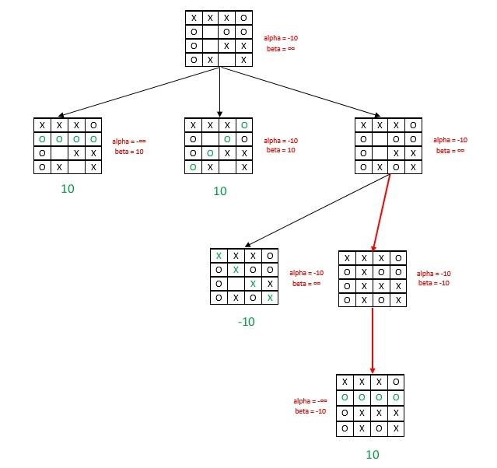

*Figure 1: State Space Representation for an instance*

# **2. ALGORITHM USED**

## 2.1 Minimax Algorithm

Minimax is a recursive algorithm which is used to choose an optimal move for a player assuming that the opponent is also playing optimally. Its objective is to minimize the maximum loss. This algorithm is based on adversarial search technique. In a normal search problem, the optimal solution would be a sequence of actions leading to a goal state. Rather in adversarial search MAX finds the contingent strategy, which specifies the MAX’s moves in the initial state, then MAX’s moves in the states resulting from every possible response by MIN and continues till the termination condition comes alternately. Furthermore, given a choice, MAX prefers to move to a state of maximum value whereas MIN prefers a state of minimum value.

## 2.2 Alpha-Beta Pruning

The problem with minimax search is that the number of game states it has to examine is exponential in the depth of the tree. The minimax algorithm recursively calls itself until any one of the agent wins or the board is full which takes a lot of computation time and makes it impossible to solve the 4X4 grid using standard minimax algorithm.

To solve this issue, we can use alpha-beta pruning algorithm which eliminates large parts of the tree from considerations by pruning the tree. When applied to a standard minimax tree, it returns the same move as minimax would, but it prunes away branches that cannot possibly influence the final decision. Basically, this algorithm applies the principle that there is no use expending search time to find out exactly how bad an alternative is if you have a better alternative. Alpha-beta pruning gets its name from the parameters that bound on the backed-up values that appears anywhere along the path: α= the value of the best choices (i.e. highest value) so far at any choice point along the path for

MAX

β= the value of the best choice (i.e. lowest value) so far at any choice point along the path for MIN.

# **3. AGENT**

## 3.1 Agent

An agent perceives its environment through sensors and acts on the environment through actuators. Its behavior is described by its function that maps the percept to action. In tic tac toe there are two agents, the computer system and human. In the AI-based tic-tac toe game the function is mapped using the minimax algorithm alongside alpha beta pruning. The agent can be further described by following factors:

Performance Measure: Number of wins or draws.

Environment: A 4x4 grid with 16 cells respectively, with opponent (human agent). The cell once occupied by a mark cannot be used again. Task environment is deterministic, fully observable, static, multi-agent, discrete, sequential.

Actuators: Display, Mouse (human agent)

Sensors: The opponent’s (human agent) input as a mouse pointer on a cell

Furthermore, it is a utility-based agent since it uses heuristics and pruning concept as utility function that measures its preferences among the states and chooses the action that leads to the best expected utility i.e. winning or tie condition for the computer system agent. The utility function is taken as +10 for winning situation of maximizing agent or AI, -10 for winning situation of minimizing agent or human player and 0 for draw condition.

## 3.2 Agent Environment Description

The basic environment for tic tac toe game agent is a 4x4 grid with 16 cells respectively with opponent as human agent. The cell once occupied by a mark cannot be used again. The agent has access to complete state of environment at any point and can detect all aspects that are relevant to the choice of action making the environment fully observable. Also, the next state of environment can be completely determined by current state and action executed which means environment is deterministic. It is a two-player game with the opponent as human agent, so it is a multi-agent environment. Beside the game environment has a finite number of states, percepts and actions, making the environment static and discrete. Also, the environment is sequential since the current choice of cell could affect all future decisions. Thus, the task environment for the tic tac toe system agent is sequential, deterministic, fully observable, static, discrete and a multi-agent.

**REFERENCES**

1. Mukherjee, Souvik. “Introduction: Video Games and Storytelling.” Video Games and Storytelling, 2015, pp. 1–21., doi:10.1057/9781137525055_1.
2. “Embodying Character in Storytelling.” Performing Story on the Contemporary Stage, 4 Feb. 2013, pp. 9–10., doi:10.1057/9781137356413.0005.
3. Huber, Amy M. “Visual Storytelling.” Telling the Design Story, pp. 101–129., doi:10.4324/9781315226132-6.